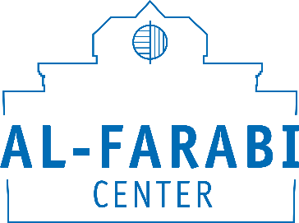 | 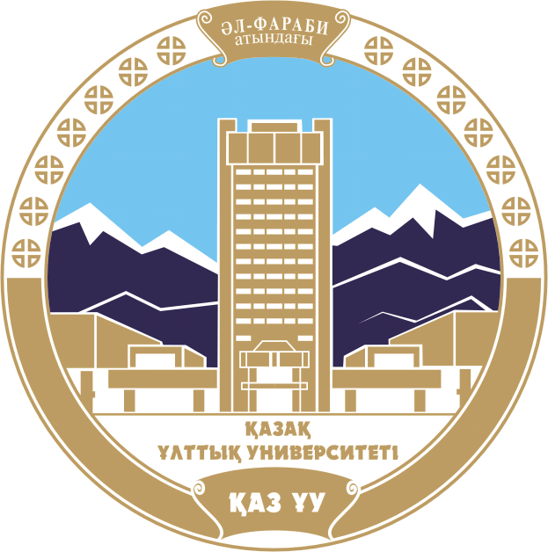
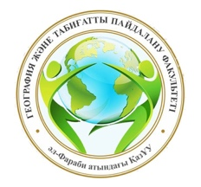

Information letter

June 30, 2020 Al-Farabi Center, together with the Department of Cartography and Geoinformatics of Faculty of Geography and Nature Management, al-Farabi KazNU, holds an online round table discussion on the topic “Harmony of the subsoil through the eyes of al-Mashani”, dedicated to the 1150th anniversary of the great thinker Abu Nasr al-Farabi.
During the round table there will be considered current problems of subsoil use in the light of the works of the great Kazakh philosopher, geodesist, surveyor and al-Farabi's follower - al-Mashani.
Working languages of the round table: Kazakh, Russian, English.
The form of participation in the round table: online (ZOOM platform).

ATTENTION: It is necessary to send the registration form of the participant to the email address Irina.Shmarova@kaznu.kz until June 25, 2020

Registration form of the participant
Surname, name (full)
Academic degree
Name of institution (full), position
Mobile Phone Number (WhatsApp)
E-mail
Topic of the report

