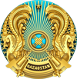  Ministry of Science and Higher Education of the Republic of Kazakhstan | 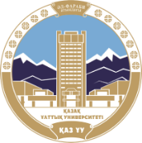  Al-Farabi Kazakh National University |  |   Institute for Cultural, Social and Civilization Studies of Ministry of Science of Islamic Republic of Iran |  | 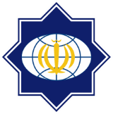  Islamic Culture and Relations Organization of Islamic Republic of Iran
 |  | 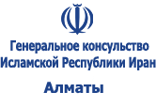

DEAR COLLEAGUES!

Al-Farabi Kazakh National University of Ministry of Science and Higher Education of the Republic of Kazakhstan and Research Institute for Cultural, Social and Civilization Studies of the Ministry of Science of the Islamic Republic of Iran, Islamic Culture and Relations Organization of the Islamic Republic of Iran, Consulate General of the Republic of Iran
holding an International Scientific and Practical Conference
"THE VIRTUOUS MAN, BENEVOLENT SOCIETY AND MODERN ETHICS IN THE LEGACY OF AL-FARABI»
on October 24, 2023

Al-Farabi is an enlightened scholar with advanced ideas who combined the best achievements of the Eastern and Western worlds. The valuable scientific and creative heritage of the thinker is of great universal significance. Considering the development of science in harmony with philosophy, morality and religious norms is the main feature of the thinker's worldview. Although a comprehensive study of Al-Farabi's legacy began in the 12th century, it is necessory to continue deep and comprehensive analysis of his spiritual world. The researches related to Al-Farabi's scientific heritage and issues on his philosophical, logical, socio-ethical views are considered in the works of domestic and foreign scientists, however it can be confidently said that they are still incomplete up to date. In addition, Al-Farabi's legacy is an eternal pillar that brings people closer and is the bridge between civilizations.
On June 19, 2022, the President of the Republic of Kazakhstan Kassym-Jomart Tokayev met with the President of the Islamic Republic of Iran Ibrahim Raisi during the official visit to Iran and Members of Official Delegations: The Ministry of Culture and Sports of the Republic of Kazakhstan and the Ministry of Culture and Islamic Orientation of the Islamic Republic of Iran have signed a Cultural Exchange Program for 2022-2025 with the participation of Heads of States. The international scientific-practical conference "The Virtuous Man, Benevolent Society and Modern Ethics in the Legacy of Al-Farabi» is organized in order to fulfill the tasks within the framework of this program.

The main directions of the Conference:
- The Virtuous Man in the Legacy of Al-Farabi and Muslim Thinkers: A Comparativist Discourse.
- Contemporary Paradigms of Benevolent City Society and Sustainability Value.
- The Doctrine of Ethics and Moral Values in the Legacy of Abu Nasr al-Farabi.
- The Role of Morality in the Maintenance of Traditions and Social Values: Continuity of Tradition and Religion in a Global World.
- Al-Farabi`s Ethical Principals on Happiness.
- The Philosophy of Language and the Language of Philosophy in the teachings of Abu Nasr Al-Farabi.
- Changes in the new quality and value orientations of personality in Kazakh and Iranian society in the context of globalization.

Events within the framework of the conference:
- Exhibition of Iranian culture.
- Exhibition of Al-Farabi's work
- Presentation of the Book: Abu Nasr Al-Farabi's "Key Points of Thought" (translated by Islam Jemenei).

TERMS OF PARTICIPATION
To participate to the Conference:
I. Submit an application in Kazakh, Russian and English languages until September 30, 2023 at: https://al-farabi.kaznu.kz/?page_id=3139
1. Full Name
2. Workplace (full name of the organization, department)
3. Work position
4.Scientific or Academic Degree
5.Scientific title
6. Contact numbers, e-mail
7. Section
8. The topic of the Report

II. Submit the electronic version of the article (.doc, .docx format) prepared according to the requirements until October 12, 2023, e-mail: farabiconferencekziran@gmail.com
Font – Times New Roman, point – 14 (summary, keywords, table, literature – point 12), alignment – width of the text, new line – 1 cm, distance between lines – 1, all sides of the page – 2 cm.
Pictures, tables, graphs, charts, etc. in the text should be given by a number (for example, Fig. 1 – the name of the picture). The number of pictures, tables, graphs, diagrams should not exceed 20% of the whole article volume (in some cases, 30%).
The length of the article (with the exception of title, author(s) information (name, country, city, place of work, scientific degree, scientific title), resume, keywords, list of references) should not be less than 2000 words.
The Organizing Committee plans to publish an electronic collection of conference materials.

Organizing Committee:
Republic of Kazakhstan, 050012, Almaty, Masanchi street, 39/47 (corner of Bogenbay batyr street), Al-Farabi KazNU, Faculty of Philosophy and Political Science, Room 403.
Contact phones: +7(727)3773330, +7(727)3773333 (ext. 1747), +77473667331, +77007890987

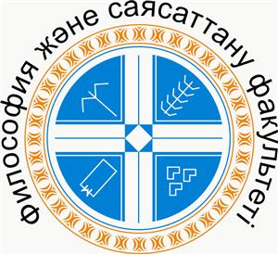 | 

